Proddy Wreath Instructions
Supplies:
Rug hooking frame or hoop
Rug hooking backing to fit your frame (such as linen, rug warp or monks cloth)
Felted wool (color of choice.) (This is a good time to use up all those little pieces of scrap wool.)
Wire wreath frame - can find them at Michael's or Amazon (Instructions are for a 12 Inch)
Marker
Tape measure
Scissors
Needle and thread
Proddy tool, large rug hooking hook, or surgical hemostat

Prepare your pattern:
- Lay wire wreath frame in center of rug hooking backing. Draw around the inside circle as close to wire as possible. (FIGURE A)
- Measure your wire from inside wire across the top to the outside wire. This is how wide your outside circle should be. (FIGURE B)
- Measure from inside line out the amount determined in step 2 and place a dot. Do this all the way around the wreath. (FIGURE A)
- Now connect the dots to make the outside line and make your wreath pattern.
(FIGURE C)
Prepare your leaves:
- Cut or tear your wool into 1 1/2 inch strips. Using scissors or rotary cutter and mat to cut 1 1/2 inch strips into 3 to 3 1/2 inch lengths. (Note you can lay about three strips together to cut into 3 inch lengths to save time.) (FIGURE D)
- To cut leaves fold a strip in half lengthwise, start cutting on fold to form a leave shape. (Note: Cut two layers at a time to speed up this process.) (FIGURE E)
- (For a 12 inch wreath you should start with about 175 to 200 leaves. You will probably need to add more - depending on how full you want it to be.) (FIGURE F)

Getting ready to Proddy:
- Stitch around the outer and center circle lines with a sewing machine. This will keep the backing from stretching. (FIGURE G)
- Start attaching your proddy leaves between the two stitch lines. Go completely around your circle. (FIGURE H)
How to Proddy using a large rug hook:
Using a large hook insert it into the backing about five holes away from the stitch line. Holding a leaf strip underneath pull one end of leaf up to the top - skip over a few holes holes and insert hook into backing again and pull up other end of leaf. Repeat this process until all the backing is filled around the entire circle. When using a Proddy tool you will be working from the underneath pushing the leaf from the back to the front.
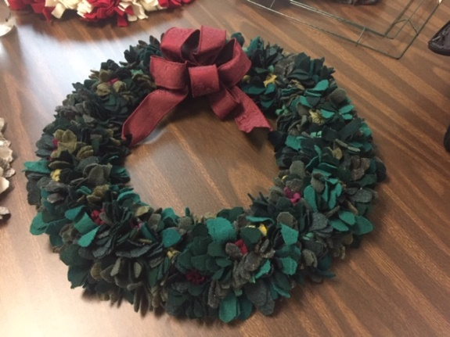
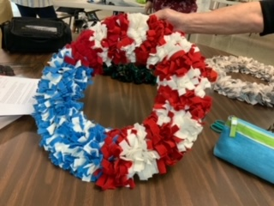
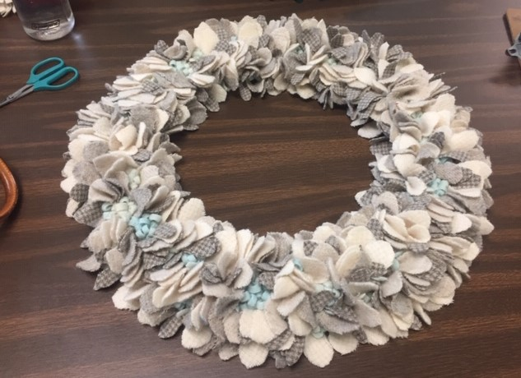
Looking forward to seeing all these creations. How to finish your wreath will be the next step coming soon. Have Fun!
Color Ideas

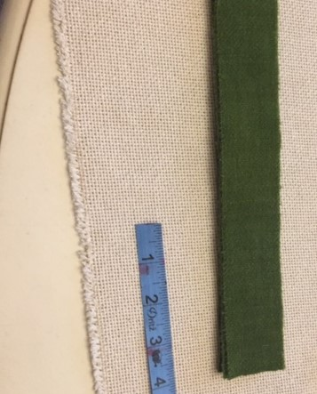
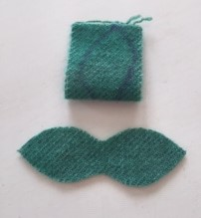
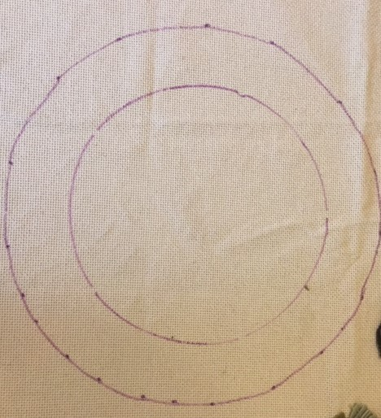
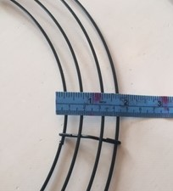
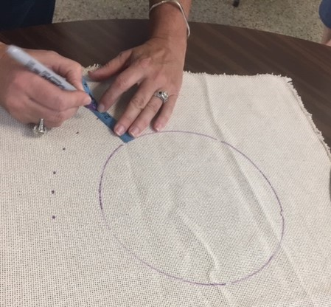
FIGURE C
FIGURE E
FIGURE D
FIGURE B
FIGURE A
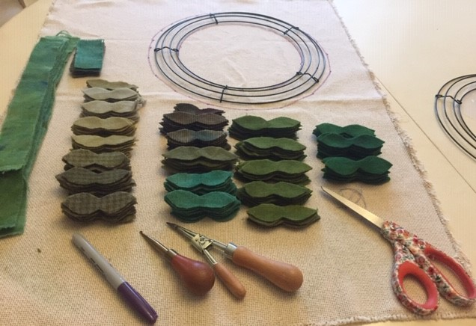
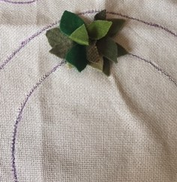
FIGURE G
FIGURE F)

