How to Finish the Wreath

Note: You may want to stitch around the outer edges to keep backing from unraveling before cutting.

1. When you think you are finished hooking take the wreath off of the hooking frame and hold it up to a window to look for voids in hooking. Fill in as necessary. It also helps to look at the back side for possible voids in hooking.
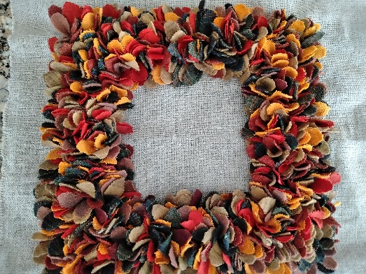

Example of finished square wreath

2. Cut out center of wreath backing leaving about 2 inches around hooked area.

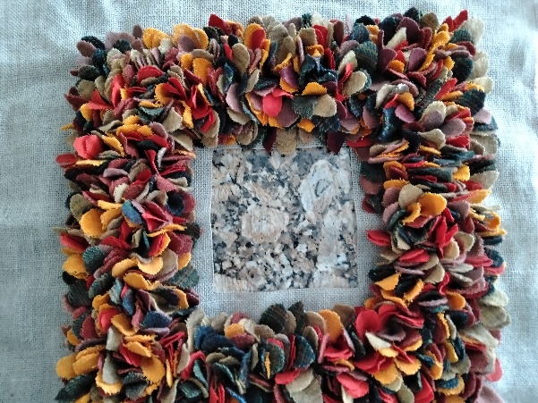

Center cut out

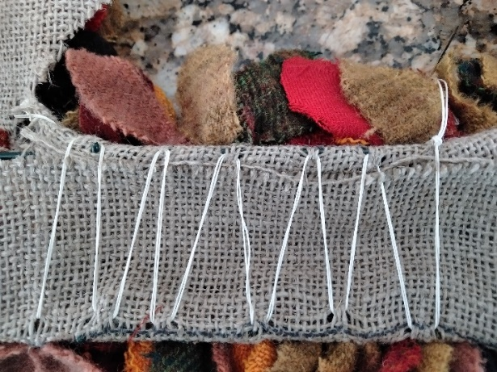
3 3. Cut backing material to fit the wreath frame leaving plenty of extra backing to lash backing onto the back of wire wreath frame, see photo.

4. Prepare backing material trace frame out on back of backing material and cut out, leaving excess to allow for turned over hem.

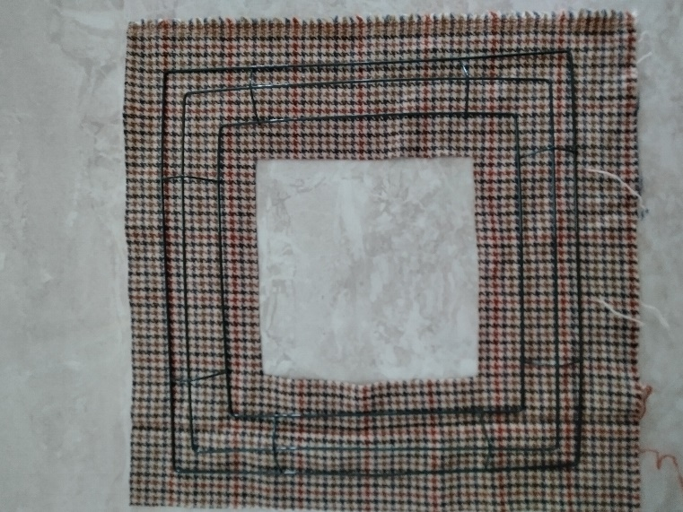

5. Pin backing to back of wreath to facilitate sewing (I use T pins as sturdy).

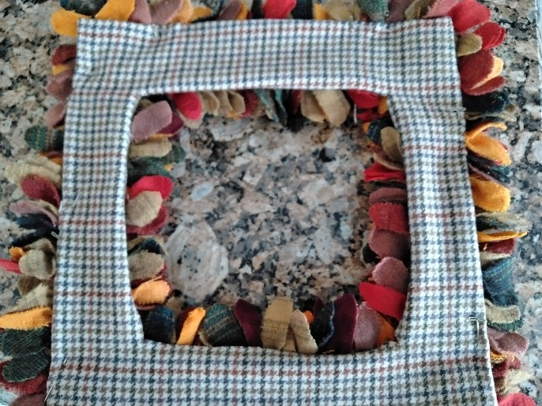

6. Determine how you want to hang the wreath. I make a wire loop with florist wire, and sew it to the back of the wreath so that it will catch a hook or nail and not be seen.

Enjoy Your Wreath!

