Proddy Flowers

Tools and supplies:
Rug hooking frame or hoop
Large rug hook or proddy tool
Rug hooking backing that fits your frame ((such as linen, rug warp, or monk's cloth)
Felted wool - your color of choice
Needle and thread
Scissors
Fabric glue

Step 1 - Determine the size of your flower.
Large Flower: Draw a 5" circle on backing, inside that circle draw a 3" circle.
Row 1 petals - 1" x 3"; Row 2 petals - 1" x 3 1/2"; Row 3 petals - 1" x 4"
Medium Flower: Draw a 4" circle on backing, inside that circle draw a 2" circle.
Row 1 petals - 1" x 3"; Row 2 - 1" x 3 1/4"; Row 3 - 1" x 3 1/2"
Small Flower: Draw a 3" circle on backing, inside that circle draw a 1" circle.
Row 1 petals 1" x 3"; Row 2 and 3 - 1" x 3 1/4"
Note: you can get multiple flowers on one piece of linen by spacing around and leaving about 2" between circles.
Preparing your petals: You can either tear or cut the strips to width. Use scissors or a rotary cutter and mat to cut to length.
Strips can vary between 1/2" and 1" width and 3" to 4" length. (Anything less than 3" length will be easier to work out of backing and greater than 4" will take much more wool.
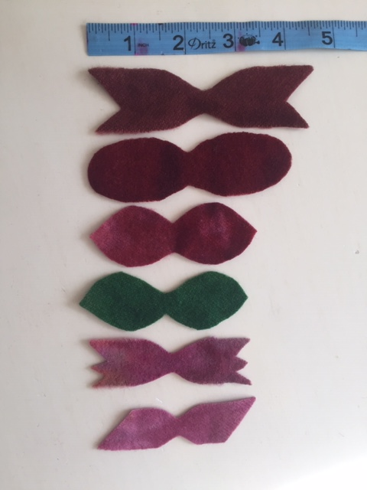
Cut all your flower petals for your choice project. See below for some suggestions on how to shape your petals.
Save your wool snippets to stuff the flower back later.

Position your backing on your rug hooking frame or hoop - pulling it very tight.
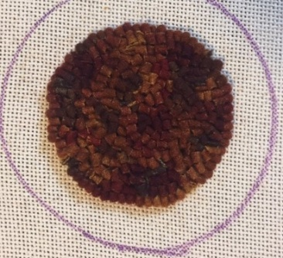
Begin filling the center with any technique of your choice. Some different ways to do the center are:
Hooked
5 - 8 cut

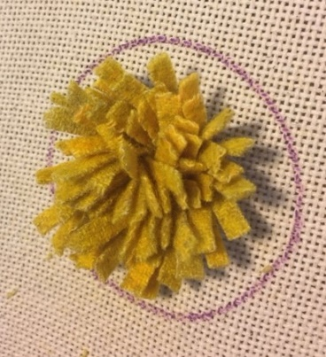
Proddy
#8 or #9 Cut
2" length

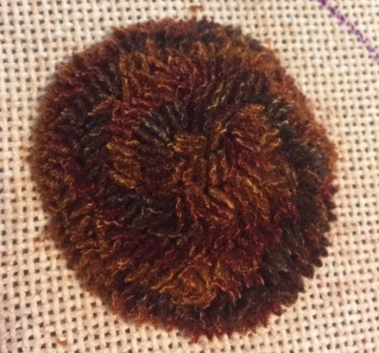
Waldoboro (sculpted)
See Below
For instructions

To proddy you will pull the petals from beneath the backing to the top using a large rug hook.
First Row:
Using your rug hook, pull one end of the petal through the backing very close to the center. Skip a few holes and pull the other end of petal through. Skip a few holes and push your hook down in a hole and pull the next petal up through the backing. Skip a few holes and pull the other end of petal through.
Continue in this manner until the first row is complete.
Repeat "first row" instructions above for all rows until the outer circle is full.

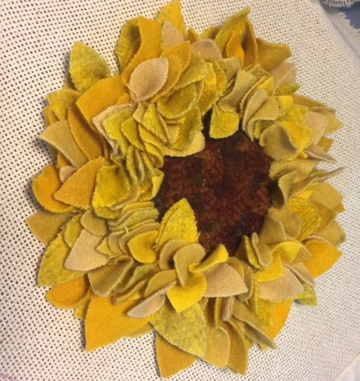

Large Flower - Hooked Center
About 70 Petals

-

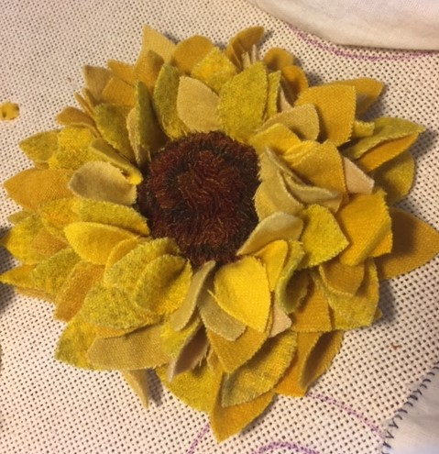

Medium Flower - Waldoboro Center
About 50 Petals

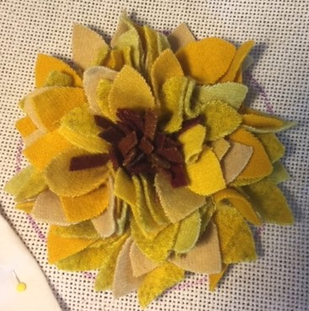

Small Flower - Proddy Center
About 40 Petals

How to finish the flower:
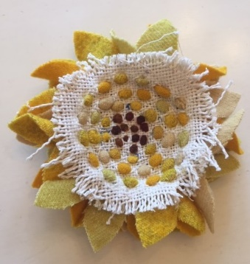
1. On the back side of your flower - rub some glue around the outside of the petals. This will keep the backing from unraveling. Let dry. (See Figure A)
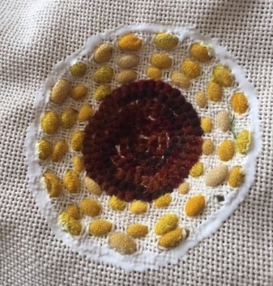
Figure A
Figure B

2. Trim the flower from the backing leaving about 1/2" border of backing around the flower. (See Figure B Above)
3. Fold the border into middle of the flower and baste stitch the backing into the center.
4. Cut a piece of wool for the back of your flower making it about 1/4" larger than the center circle - depending on the size of your flower from step 1. (Color of wool backing is of your choice.)
5. Another way to finish the back is hook a circle about 1/4" larger than your center circle. Prepare the hooked back following instructions 1 - 3 from above.
6. Stitch around the edge of the backer piece of wool making sure to stitch to the base of the petals and not the backing. When you have about 1" opening - stuff your snippets inside the flower backer to round it out and continue to close.
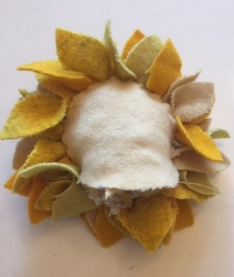
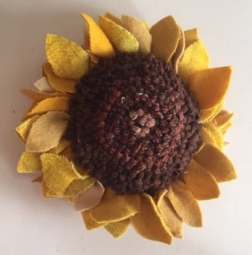
Wool Back
Hooked Back

Have fun making these Proddy Flowers! Be creative and display them in different ways. Some ideas are shown below!
Use your flowers in many ways.
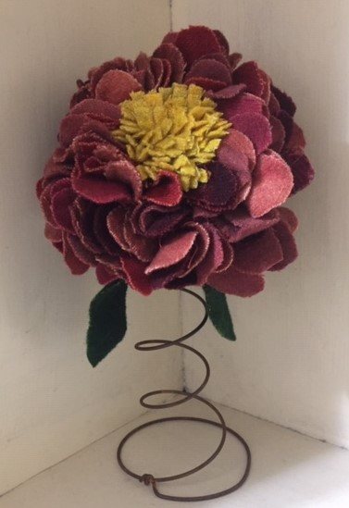
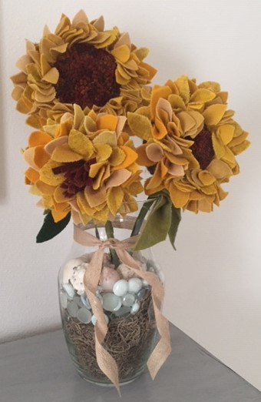
Mount them on a stem and display in a vase
Mount them on a rusty spring.

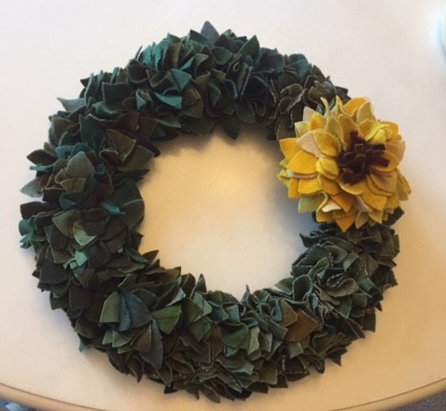

Attach them to a Proddy Wreath.

Share your completed projects on our Facebook page.
"The Gator Rug Hooking Group"

LeLet
Waldoboro Instructions:
This technique makes for a strong three dimensional statement. Works great for Black - Eyed Susan, Shasta Daisies, and Sunflowers. Tweed wool add realism to these centers.
For Waldoboro - break all rules of hooking and never skip any holes when making loops.
To begin, start on the outside of the center circle and hook a row of normal height loops using a #6 cut. (For a softer finished a smaller cut can be used.)
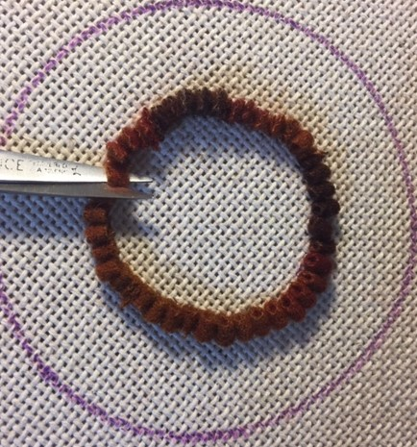
Clip each loop of the first row - making all tails the same size.

Hook the second row butted up next to first row and raise the loops a little higher than the first row. Clip the loops as before.
Continue making higher rows until the loops "stair step" up to the center.
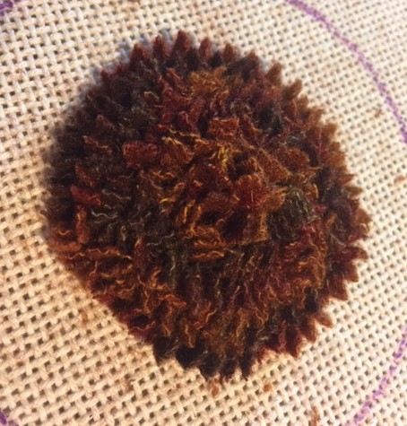
Proddy center before sculpted
Take the pattern off the frame for the next step. (This will be messy.)

Sculpt a smooth and rounded center.
Carefully trim away the edges of the wool to smooth and round the surface toward the center. Placing a finger underneath and push up on the center makes it easier to trim.
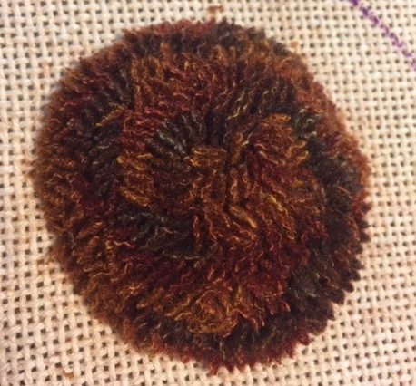

Proddy center after sculpted

Remember it is easier to take more off than put more back on so trim gradually.

Waldoboro does take a little more work, but the end result is spectacular.

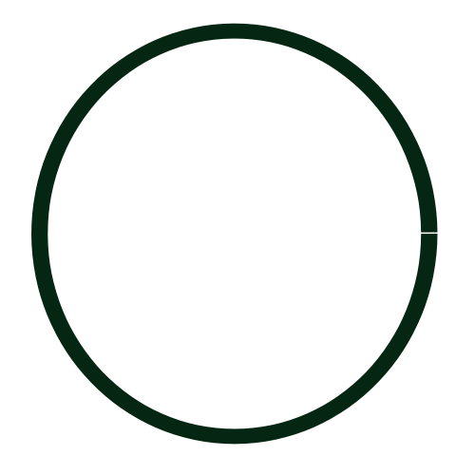

4 inch circle

3 inch circle

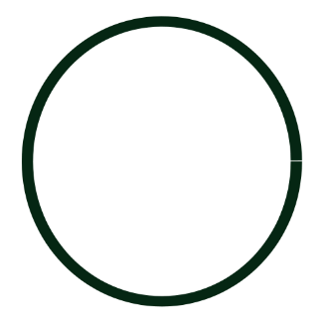
1 inch circle
5 inch circle
2 inch circle

